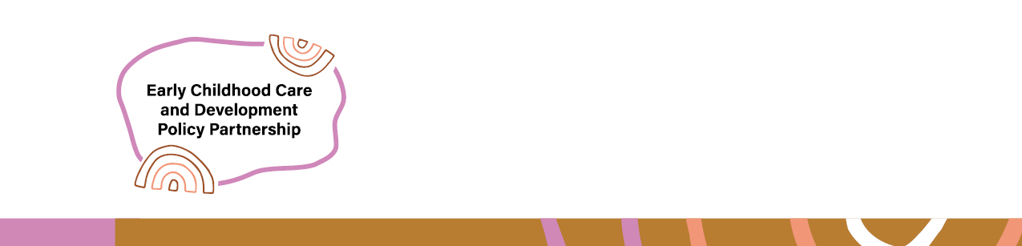

Early Childhood Care and Development Policy Partnership
  - Meeting 12 Outcomes – 12-13 November 2025
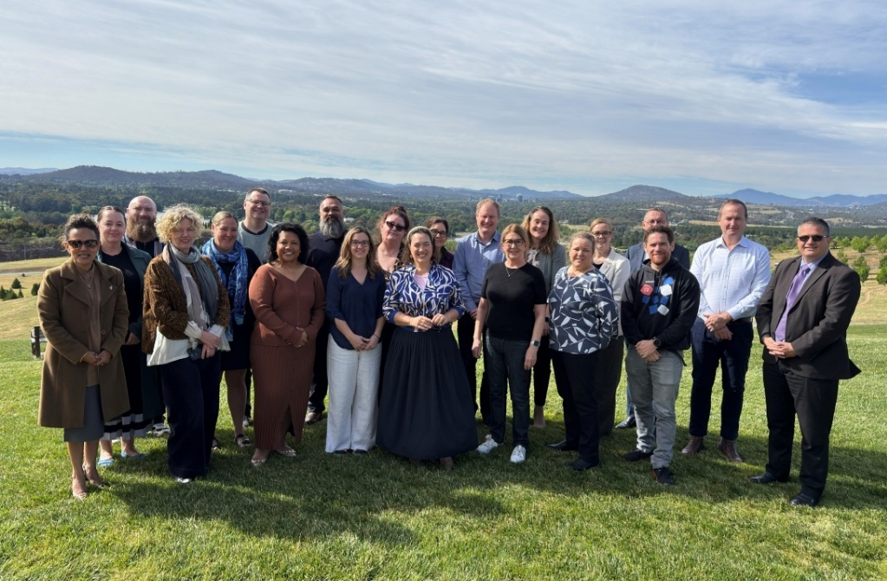
The Early Childhood Care and Development Policy Partnership (ECCDPP, Partnership) held its twelfth meeting in Canberra on 12-13 November 2025 on Ngunnawal Country.
Selina Walker, Ngunnawal Traditional Owner and Chair of Yerrabi, performed a Welcome to Country. Selina spoke about the importance of continuing to reflect on colonialism and the role each of us can play in reconciliation. Selina also reflected on the importance of the Partnership’s work to support Aboriginal and Torres Strait Islander children, particularly those with developmental delay and disability.
Members of the Early Childhood and Development Policy Partnership on Ngunnawal Country
The meeting was co-chaired by Catherine Liddle, CEO, SNAICC – National Voice for our Children (SNAICC) and Kylie Crane, Deputy Secretary, Early Childhood, Australian Government Department of Education. It was attended by Aboriginal and Torres Strait Islander independent and peak body representatives and representatives from all Australian governments. A full list of attendees is located from page 4.
As part of the meeting, Co-Chairs updated members on the work of the Australian Government and SNAICC in partnership to close the gap in early childhood outcomes, along with representatives from the Australian Government National Indigenous Australians Agency and Department of Social Services (DSS).

Progressing the Partnership’s Priorities
The Partnership’s priorities are the agreed policy reform areas on which the Partnership will focus its work. The priorities aim to drive concrete action to advance the safety, development and wellbeing of children and to meet Closing the Gap targets 2, 3, 4, 12 and 13 and the cross-cutting area of disability. A full list of priorities can be found on the SNAICC website.

Priority 1A
Increase the proportion of child and family services funding to ACCOs with consideration to the proportion of Aboriginal and Torres Strait Islander children involved in child protection systems, across Commonwealth and jurisdictions in line with the recommendations of the Stronger ACCOs, Stronger Families Report and the Family Matters Report.
Aboriginal and Torres Strait Islander Community Controlled Organisations (ACCOs) are best placed to support Aboriginal and Torres Strait Islander children, because they provide culturally safe, wrap-around services that are tailored to the needs of local families. ACCOs also play an important role as a vehicle for communities to determine the systems and services that support their children and families, and a stronger mechanism for accountability to Aboriginal and Torres Strait Islander communities. However, they need adequate funding to perform these roles.
Letitia Hope, Deputy Secretary, Families and Communities, DSS, provided an update on the Australian Government’s work to increase the proportion of child and family services funding to ACCOs. She noted that most Safe and Supported Shared Decision-Making Committee members recently endorsed the National Child and Family Investment Strategy. The Strategy supports the shift to transition funding to ACCOs and towards early and targeted supports for families to prevent contact with child protection systems.
Letitia also noted that work was underway to develop a new approach to programs for families and children. The proposed changes respond to feedback the government has received, including through the Families and Children Activity: Review of Children, Youth and Parenting Programs consultation held in 2024-25, that programs need to be more inclusive and provide the flexibility that is needed to respond to local need. This reform presents a critical opportunity to increase the number of ACCOs delivering supports for Aboriginal and Torres Strait Islander children. DSS invited members to participate in the planned consultations, available on DSS Engage until 5 December.
The First Nations Caucus noted that the new program must include specific targets for the proportion of funding that would be transitioned to ACCOs, and the reforms should be delivered through shared decision-making, in line with the National Agreement on Closing the Gap. Professor Paul Gray, Independent Aboriginal and Torres Strait Islander member, encouraged governments to take the opportunity of the funding transition to think more deeply about the relationship between governments and Aboriginal and Torres Strait Islander communities, in line with the Priority Reforms and Closing the Gap reviews. In particular, he emphasised moving beyond seeing ACCOs merely as possible service providers within a government-administered system, recognising how Aboriginal and Torres Strait Islander community-based governance can contribute more broadly to system design and administration, more in line with the principle of self-determination.

Priority 1B
Develop models for adequate and coordinated funding of ACCOs that deliver child and family services, in consideration of the real cost of service delivery, including core functions, capital infrastructure, wage parity and other workforce costs.
Current funding models for ACCOs delivering child and family services are often fragmented and designed for non-Indigenous services, and do not consistently provide ACCOs with the resources they need to build a sustainable workforce and deliver the supports families need to keep children safe and strong in their culture.
Catherine Liddle provided an update on the research SNAICC has been commissioned to undertake on behalf of the ECCDPP, to develop sustainable funding models for ACCOs delivering child and family services. SNAICC has completed a literature review to inform the project. SNAICC is also engaging with ACCOs across the country to understand the ways they support children and families, how current funding approaches affect the services they deliver and what changes may be required to allow them to better support families and their communities. It is anticipated that early findings from this project will inform the new approach to programs for families and children.

Other ECCDPP work

Closing the Gap Implementation Planning
Government members provided updates on how they were working with Aboriginal and Torres Strait Islander people on their Closing the Gap Implementation Plans, focusing on the components relating to early childhood care and development. These plans outline how governments are taking forward the National Agreement on Closing the Gap in their jurisdictions, improve outcomes for Aboriginal and Torres Strait Islander people. Government members reflected it was critical to embed the priority reforms in their planning. They also discussed the challenge of providing a clear narrative around work to close the gap, given the broad range of initiatives underway across jurisdictions.
The First Nations Caucus reflected that jurisdictions were making progress in engaging with Aboriginal and Torres Strait Islander people and organisations. However, there is still much more to be done to ensure decision making and policy reform is made in accordance with the commitments under the National Agreement on Closing the Gap and policies targeted to Aboriginal and Torres Strait Islander people are made with the input of the relevant peak bodies.
The First Nations Caucus noted that governments must focus on creating the authorising environment and system changes so they can respond to community feedback on what was needed to improve outcomes for children. The Caucus also called on all governments to urgently deliver on their commitments to establish Independent Mechanisms to support, monitor, and report on the transformation of governments to close the gap.

Thriving Kids reforms
Dr Liz Develin, Deputy Secretary, and Lisha Jackman, Assistant Secretary, from the Department of Health, Disability and Ageing provided the members with an update on the Thriving Kids reforms. The reforms will establish supports for children 8 and under with developmental delay and/or autism with mild to moderate support needs, and their families, carers and kin.
This update was the start of engagement with the ECCDPP. Members reflected that the Partnership was the ideal forum under the National Agreement on Closing the Gap to be providing input into the reforms to ensure they reflected the needs of Aboriginal and Torres Strait Islander children and the context within each jurisdiction.
The First Nations Caucus noted that Aboriginal and Torres Strait Islander children face the highest rates of developmental delay and disability and the greatest barriers to accessing support. Therefore, it is critical that these reforms are designed in strong partnership with Aboriginal and Torres Strait Islander people through shared decision-making, and cultural safety is central to the reforms. They noted that ACCOs are leading the way in providing holistic supports for children and need to be supported to continue to build on these strengths, including through a dedicated funding model for ACCO integrated early years services.
State and territory government members of the ECCDPP noted that the success of this program relied on having sufficient funding and time to establish the necessary supports for families. They also noted the importance of clear communication about the program so families felt confident that their children would be supported. Members noted that care needed to be taken to make sure regional and remote communities had the supports they needed. The Department of Health, Disability and Ageing acknowledged the opportunity to work closely with the Partnership on the design of the reforms in 2026.

SNAICC Youth Voice
Representatives from the SNAICC Youth Voice Advisory Group met with the ECCDPP to provide an overview of their work to establish a SNAICC Youth Voice. SNAICC has met with young people, policy groups and Children’s Commissioners across Australia to understand existing youth voice mechanisms. SNAICC has now established a formal Youth Sub-Committee to the SNAICC Council, which will work in a broader ecosystem of existing youth voice mechanisms across the country.
Members discussed the ways they could strengthen their involvement with young people in their own jurisdictions, building on existing work. They also discussed supporting Aboriginal and Torres Strait Islander young people to connect with their family and ancestry. The First Nations Caucus reflected on the need for governments to protect Indigenous Intellectual Property when engaging with Aboriginal and Torres Strait Islander young people.

Evaluation of the ECCDPP
Members discussed and provided feedback on the draft ECCDPP evaluation report from yamagigu Consulting Pty Ltd. The final report will be published early in 2026 once finalised.

ECCDPP Strategic Plan
Members held a workshop to develop the second ECCDPP Strategic Plan, for 2026-2028. Members discussed focus areas that should be captured in the Strategic Plan and opportunities the Partnership should respond to in the next three years. Members highlighted the need to continue to be ambitious and the importance of building on the Partnership’s achievements to date. The First Nations Caucus noted that it was critical for the Plan to reflect the Partnership’s role driving progress on the Priority Reforms under the National Agreement on Closing the Gap.

Next meeting
The Partnership will meet again in March 2026.

Attendees/Apologies
Name | Representing
Coalition of Peaks representatives
Catherine Liddle | SNAICC – National Voice for our Children (SNAICC)
Donnella Mills | National Aboriginal Community Controlled Health Organisation (NACCHO)
Neville Atkinson (Apology) | Victorian Aboriginal Education Association Incorporated
Lisa Coulson | Tasmanian Aboriginal Centre
Rhys Howard | First Peoples Disability Network
Kylie Degenhardt (Apology) | South Australian Aboriginal Community Controlled Organisation (SAACCON)
Independent Aboriginal and Torres Strait Islander representatives
Darcy Cavanagh | Independent representative
Paul Gray | Independent representative
Garth Morgan (online) | Independent representative
Joanne Della Bona (online day 1) | Independent representative
Elizabeth Cox (Apology) | Independent Representative
Government representatives
Kylie Crane | Australian Government, Department of Education
Mark Barraket | New South Wales Government
Mathew Lundgren | Victorian Government
Tania Porter | Queensland Government
Melanie Samuels | Western Australia Government
Bec Curtain (proxy for Kim Little) | South Australia Government
Peter Whitcombe | Tasmania Government
Liam McNicholas (proxy for Nicole Moore) | Australian Capital Territory Government
Rachel McMillian (proxy for Karen Broadfoot) | Northern Territory Government
Partners
Shantai Croisdale (proxy for Muriel Bamblett) | SNAICC – National Voice for our Children (SNAICC)
John Leha (day 1) | CEO of AbSec – NSW Child, Family and Community Peak Aboriginal Corporation
Phillip Brooks | CEO of Queensland Aboriginal and Torres Strait Islander Child Protection Peak (QATSICPP)
Letitia Hope (online) | Australian Government, Department of Social Services
Deborah Fulton (proxy for Julie-Ann Guivarra) | Australian Government, National Indigenous Australians Agency
Stuart Malcher | New South Wales Government
Jenine Godwin-Thompson (proxy for Simone Corin) | Victorian Government
Ron Weatherall | Queensland Government
Raechelle Lee | Western Australia Government
Shirley Smith (proxy for Jackie Bray) | South Australian Government
Jodee Wilson (day 2) | Tasmanian Government
Telesha Newman (proxy for Chris Simpson) | Australian Capital Territory Government
Audrey Billias (proxy for Aderyn Chatterton) | Northern Territory Government

